Enmao Diao Haoli Du

Project 2C

In part B, we set up road network of the GT campus with world.csv. Some assumptions are made in this simulator: people follow regular traffic rules in that people only drive in the direction of the street. Cars may not make a "U turn" when driving on a particular street; however, the driver may choose to drive back the road which (s)he came from if a street is 2 way. The capacity of the road is calculated using the real life GT campus width / # of cells horizontally * the street length in unit cells. A car may not choose to drive back when the driver has reached an exit. If a driver is facing an exit among all the branches at an intersection, the driver will take the route to the exit.

We instantiate the simulator with the road network of nodes. Both parking and streets are nodes. Each node has a start and end point which indicates the direction of the street; each node has children nodes which indicates the road connections. If a street is 2 way, a new node with opposite direction will be generated to account for the counter flow.

We also implement three kinds of random number generators.

In part C, we will use Priority Queue to handle all the events. We defined 4 types of events:

1.In Parking: The initial event for all cars.

2.On Street

3.At Intersection

4.Exit

For a given event, a time will be associated with it. The time indicates when this event will be processed. For event 1 and 2, the simulator will check if the car can in fact complete the action and move on to the next action. An action can be completed if there are no other cars in front this car. If the car cannot leave this street and arrive at an intersection or leave the parking lot, a new event will be generated with a later time associated with the same car for the same action. This can model a traffic backup correctly in that it's not known how long it takes to complete this action of leaving the parking lot or leaving this street. We will not only use random numbers for determining time interval but we will also use them for handling intersection event. Testing of those random variables are by plotting the samples of those different distributions onto a graph and visually confirm whether it is a uniform, or exponential distribution.

In Part C, we implemented four types of events that were mentioned above and added many parameters to enhance the reality and generality of our model. Our model has a graph with nodes and vertices. Each node represents the start point of one record from world.csv. Then every edge represents the connection between each record based on their start and end point. The node class has child node to represent the vertices.

To make your life and our lives easy, an animation of the simulation is made. A graph of the world shows the number of cars at each node at any given time and another graph shows the number of car exiting over time. The graph is updated every 10,000 iterations.

In the red-flashing mode, we use the random generator developed in part B to help us simulating time elapse and decision at intersection. We use uniform random numbers to decide which direction the car may turn. In addition to that, we use a parameter EAST_TENDENCY to give more weight to the path that directs east. If the intersection has a path to the east direction, it will probably decide to follow that direction. If not, then we use the random generator to decide. If EAST_TENDENCY is zero, there is no weight given these east direction paths. We get some very interesting results from this parameter.

In the Cop mode, enabled by setting COP_MODE = 1 under parameters.py, we added many other parameters and hope that we can simulate the real world. First the policy that the cops use to guide the cars is based on the congestion level and path travel time. Congestion level is determined by the number of cars over capacity of one node. The path travel time is configured in advance with the distance over car speed. Simulation parameters like the car speed are listed below. We also normalize the congestion level and path travel time in order to take both into account in the same scale. We also have a trade-off parameter SPACE_TIME_TRADEOFF to weigh on these two parameters different. Based on our experiment, in this graph, it would be better to rely more on congestion level than path travel time.

Meanwhile, in order to decide the location of cops, we use some abstract principle to place the cops. In reality, cops mostly appear when there is a congestion at intersection or a intersection is very big and possibly has many turns. So we set COP_INTERSECTION_THRESHOLD COP_CONGESTION_THRESHOLD to help use decide where these cops should appear. The default mode is to purely decide the position with the number of turns with the parameter IF_MUTATE. In this case, the cops will not change their positions constantly. We added one more interesting feature to our model which turns out to be quite useful and realistic. Because cops are also humans and they will also have to evacuate, we decide to let cops to leave their position when the number of people exit reach a threshold COP_EVACUATION_THRESHOLD. Previously, we encounter situations that in the end the cops prevent the cars to leave the node and force them to circulate in a closed cycle. With this functionality, as the cops leave, the cars will turn into red-flashing mode and evacuate.

In the future, we might add more features like let cops to handle dead-end and be aware of the conditions of more levels of child nodes. In our model, each node acts like a root node for a tree. So we might use some graph theory to give the cops ability to judge the condition more wisely.

Here is what we found:

First we looked at how the east tendency affects the speed of the evacuations. We tested with EAST_TENDENCY of 0, 0.2, 0.4, 0.6, 0.8 and 1. The results of those can be seen below:

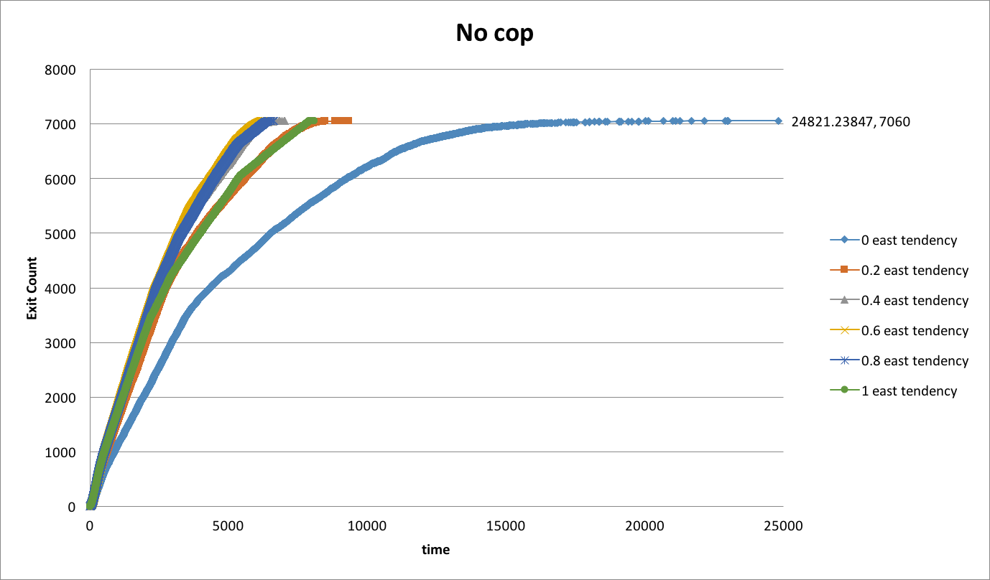

Figure 1. Simulation time vs. Exit Count for varying east tendency

As you can see, surprisingly, the runs with 0.6 east tendency finished the quickest at 6388 time units. In fact, all of 0.4, 0.6 and 0.8 yielded good results, and both of 0.2 and 0.8 produced bad results. This can possibly be explained that if everyone wants to go east, then the roads that go east will be extremely crowded, thus slowing the evacuation down; however, if very few people want to go east, then those people are spending too much time making random actions hoping to get to a node that’s an exit. This also wastes a lot of time. Having the right amount of people trying to go east at a particular time will work the best.

From that, it’s really hard to see how the cops can beat this system and have a more optimal performance. We ran trials with number of intersection threshold at 1, 3 and 4. When threshold is at 1, at every intersection, there is a cop. It produced results that are much worse. It can be seen from the kink in the graph that as soon as the cops leave, the speed of cars leaving the system is increased. This gives us ides to try out a lower evacuation threshold, so that the cops can have less of an impact at that stage of the evacuation. 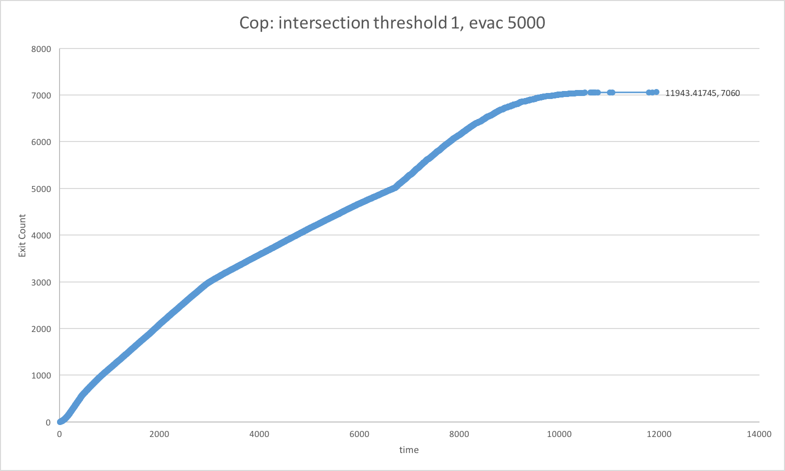

Figure 2. Simulation time vs. Exit Count for intersection threshold of 1 and cop evacuation when 5000 cars exit.

We then tested evacuation level of 3000, and here are the results: 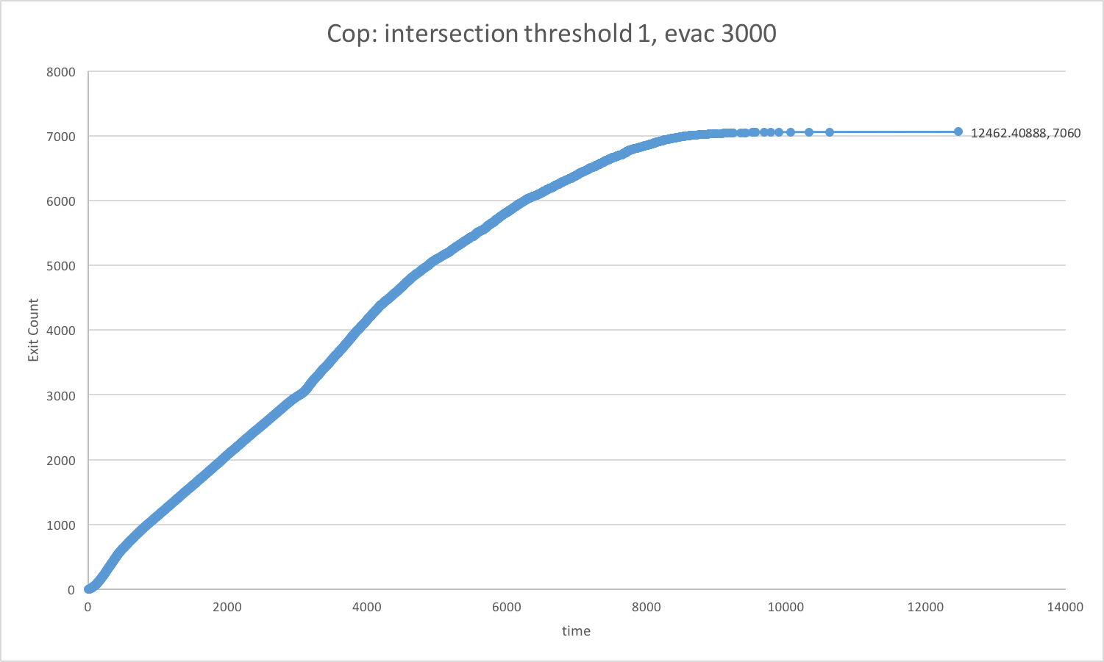

Figure 3. Simulation time vs. Exit Count for intersection threshold of 1 and cop evacuation when 3000 car exit.

There is also a kink on the graph of this one. There is no significant difference in the final evacuation time between the 2, but it’s easy to see that the two graphs differ greatly. It took the last driver a lot more iterations to actually get to an exit. It’s hard to objectively say which one is better, so I think it’s safe to say that both of them are not ideal evacuation plans.

We then compare the difference between when there is and isn’t a cop direction traffic. East tendency of 0.6 is used for the no cop trials and 1,3,4 number of intersections are used as threshold for where are cops.

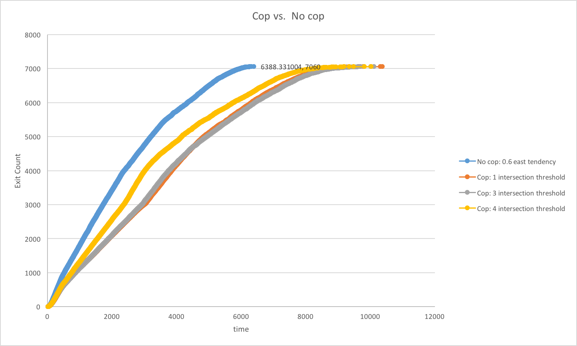

Figure 4. Simulation time vs. Exit Count for intersection threshold of 1, 3, 4 when 3000 car exit and no cop with 0.6 east tendency.

It’s easy to see that, with fewer number of cops, more people can get to the safe area faster. The slope the lines of the yellow and gray and red really show that cops don’t have all the information to direct traffic well, thus the fewer of them to disturb the traffic, the better.

In conclusion, drivers will be better off if no cops are involved in directing the flow of traffic given about 60% of them is trying to go east at a given time.